**Electrical Redesign of the Altitude Control System**

**Previous Design:**

In the past the ACS (Altitude Control System) on board computer was powered by a Teensy 3.5 Arduino module. The Teensy 3.5 Arduino was in charge of the following components: SD Card read/write, Actuator, Bi-Directional Level Shifter, Pressure Sensor, and a Voltage Regulator. These components where used to determine the pressure from which altitude could be derived from, once the altitude was derived the Actuator would be moved to the correct position so that the right amount of helium can be released.

This was a good design but it could still be improved upon. I replaced the Teensy 3.5 with a new module which would grant us Wi-Fi capabilities and server hosting capabilities. Using this web server, our Adler team would be able to create a graphical user interface where we can manage the settings on the ACS, without having to do it manually on the faceplate.

**Electrical Requirements for the ACS:**

1. **Measure air pressure**
   1. Need to measure the air pressure to calculate the altitude.
2. **Measure internal and external temperature**
   1. To monitor the temperature, to know when to turn the heating components on and off.
3. **Move the Actuator**
4. Allows the balloon to transition from different stages.
5. **Store flight data**
6. Data of currentTime, switchState, programState, currentActuatorExtension, floatStartTime, currentPressure, currentAltitude, currentDAdt, currentTemp currentTeensyTemp
7. **Shift 3v to 5v for the actuator**
   1. The actuator requires 5v to operate so we need to bump up the voltage output by the Node

**Electrical Design Improvements to the Altitude Control System**

The new ACS design upgraded from Teensy 3.5 to NODE MCU in order to have wireless data transferred back and forth. The NODE MCU connected to the links below :

[MS5607 (FH Custom Board)](https://drive.google.com/drive/folders/16ZJGZTs825R1n1g7wyLTM0qxeri8nhSK) , [INA219 DC Current Monitor](https://www.adafruit.com/product/904), [NODEMCU-32s](https://wiki.ai-thinker.com/_media/esp32/docs/nodemcu-32s_product_specification.pdf) (other [Link](https://www.handsontec.com/pdf_learn/esp8266-V10.pdf)), [4-channel I2C-safe Bi-directional Logic Level Converter - BSS138](https://www.adafruit.com/product/757), [SD Card](https://drive.google.com/drive/folders/1KwhH_GqyQZ7islSEdBvZaxZfuhbOMYXJ), [Actuator](https://drive.google.com/drive/folders/101-dsSmR7bPt5kwv_dFBjvtoo13Dyn7v), Voltage Regulator 5V

A wifi-enabled arduino was incorporated in the next design. With the NODE MCU, a web-server that hosts the mission data was set up. Housekeeping data such as a battery monitor, temperature monitor, altitude feedback were obtained from the new design. We were also able to incorporate the current monitor, and the external SD card into the primary board.

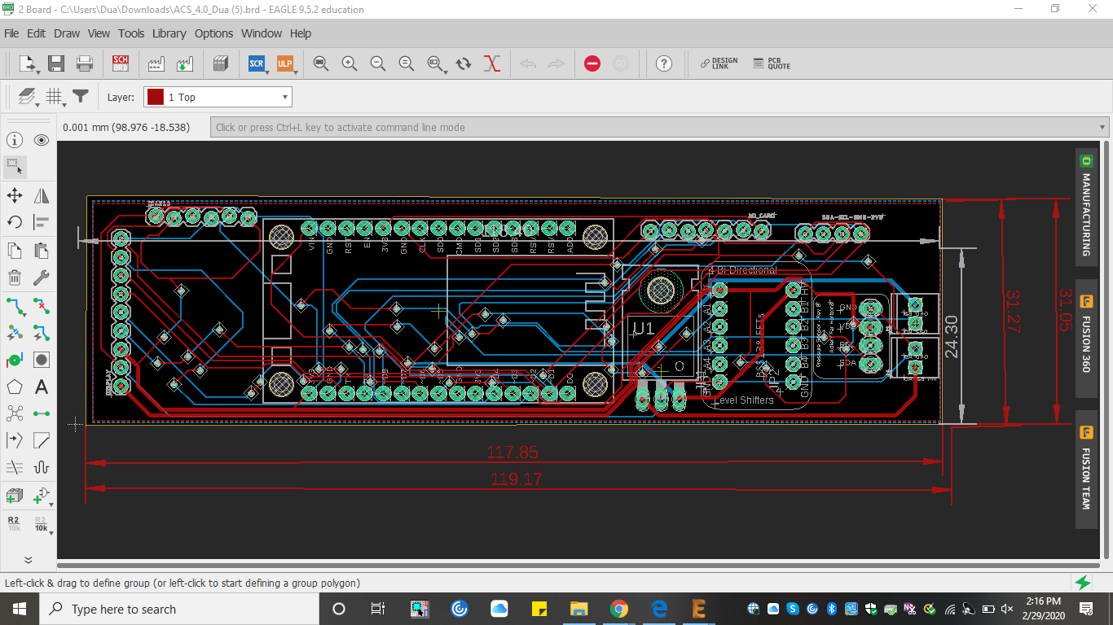

**Future Goals:**

Finish the code for the NODEMCU, implement design in the balloon flight.